Assignment 4:

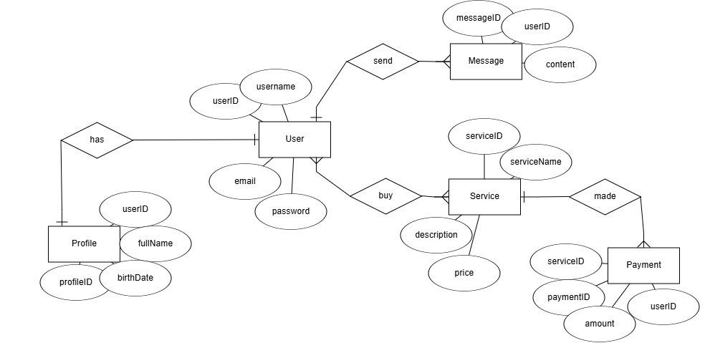1- ER diagram:

2- Table creation:

a- Users table:

CREATE TABLE Users (

userID INT GENERATED BY DEFAULT AS IDENTITY PRIMARY KEY,

username VARCHAR2(50) UNIQUE NOT NULL,

email VARCHAR2(100) UNIQUE NOT NULL,

password VARCHAR2(255) NOT NULL

);

b- Profiles table:

CREATE TABLE Profiles (

profileID INT GENERATED BY DEFAULT AS IDENTITY PRIMARY KEY,

userID INT UNIQUE,

fullName VARCHAR2(100),

date_of_birth DATE,

CONSTRAINT fk_profile_user FOREIGN KEY (userID) REFERENCES Users(userID)

);

c- Message table:

CREATE TABLE Message (

messageID INT GENERATED BY DEFAULT AS IDENTITY PRIMARY KEY,

userID INT,

mContent VARCHAR2(1000),

CONSTRAINT fk_message_user FOREIGN KEY (userID) REFERENCES Users(userID) ON DELETE CASCADE

);

d- Service table:

CREATE TABLE Service (

serviceID INT GENERATED BY DEFAULT AS IDENTITY PRIMARY KEY,

serviceName VARCHAR2(100),

description VARCHAR2(500),

price NUMBER(10, 2)

);

e- Payment table:

CREATE TABLE Payment (

paymentID INT GENERATED BY DEFAULT AS IDENTITY PRIMARY KEY,

userID INT,

serviceID INT,

amount NUMBER(10, 2),

CONSTRAINT fk_payment_user FOREIGN KEY (userID) REFERENCES Users(userID) ON DELETE CASCADE,

CONSTRAINT fk_payment_service FOREIGN KEY (serviceID) REFERENCES Service(serviceID) ON DELETE CASCADE

);

f- UserService table:

CREATE TABLE UserService (

userID INT,

serviceID INT,

CONSTRAINT fk_userservice_user FOREIGN KEY (userID) REFERENCES Users(userID) ON DELETE CASCADE,

CONSTRAINT fk_userservice_service FOREIGN KEY (serviceID) REFERENCES Service(serviceID) ON DELETE CASCADE,

PRIMARY KEY (userID, serviceID)

);

3- Adding 3 record to each table:

a- Users table:

INSERT INTO Users (username, email, password) VALUES ('Mohannad', 'moh@gmail.com', 'pwd123');

INSERT INTO Users ( username, email, password) VALUES ('Abdullah', 'abd@gmail.com', 'pwd456');

INSERT INTO Users (username, email, password) VALUES ('Deema', 'Deema@gmail.com', 'pwd789');

* Result:

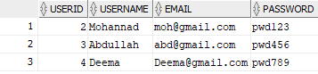

b- Profiles table:

INSERT INTO Profiles (userID, fullName, birthDate) VALUES (2, 'Mohannad', TO_DATE('1990-05-14', 'YYYY-MM-DD'));

INSERT INTO Profiles (userID, fullName, birthDate) VALUES (3, 'Abdullah', TO_DATE('1992-08-22', 'YYYY-MM-DD'));

INSERT INTO Profiles (userID, fullName, birthDate) VALUES (4, 'Deema', TO_DATE('1988-03-10', 'YYYY-MM-DD'));

* Result:

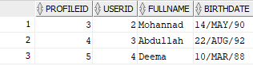

c- Message table:

INSERT INTO Message (userID, mcontent) VALUES (2, 'Hello, how are you?');

INSERT INTO Message (userID, mcontent) VALUES (3, 'Hi, all good. How about you?');

INSERT INTO Message (userID, mcontent) VALUES (4, 'Hey everyone, I am joining the chat.');

* Result:

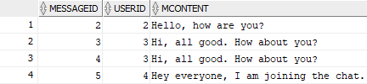

d- Service table:

INSERT INTO Service (serviceName, description, price) VALUES ('Premium Messaging', 'Allows unlimited messages', 9.99);

INSERT INTO Service (serviceName, description, price) VALUES ('Ad-free Experience', 'Removes all ads', 4.99);

INSERT INTO Service (serviceName, description, price) VALUES ('Cloud Storage', 'Provides 100GB of cloud storage', 14.99);

* Result:

e- Payment table:

INSERT INTO Payment (userID, serviceID, amount) VALUES (2, 1, 9.99);

INSERT INTO Payment (userID, serviceID, amount) VALUES (3, 2, 4.99);

INSERT INTO Payment (userID, serviceID, amount) VALUES (4, 3, 14.99);

* Result:

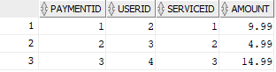

f- UserService table:

INSERT INTO UserService (userID, serviceID) VALUES (2, 1);

INSERT INTO UserService (userID, serviceID) VALUES (3, 2);

INSERT INTO UserService (userID, serviceID) VALUES (4, 3);

* Result:

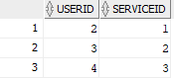

4- Updating 1 record from each table:

a- Users table:

UPDATE Users SET email = 'moh2@hotmail.com' WHERE userID = 2;



* Result:



b- Profiles table:

UPDATE Profiles SET fullName = 'Mohannad Jaradat' WHERE userID = 2;

* Result:

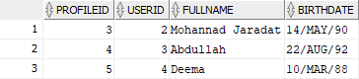



c- Message table:

UPDATE Message SET mcontent = 'Hello, this is the updated message' WHERE messageID = 4;

* Result:



d- Service table:

UPDATE Service SET price = 25.55 WHERE serviceID = 1;

* Result:

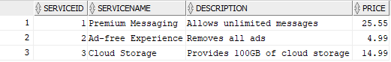



e- Payment table:

UPDATE Payment SET amount = 50.00 WHERE paymentID = 3;

* Result:

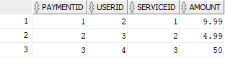



5- Deleting 1 record from each table:

a- Profiles table:

DELETE FORM Profiles WHERE profileID = 5;



* Result:

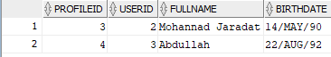

b- Users table:

DELETE FROM Users WHERE userID = 4;

* Result:

c- Message table:

DELETE FROM Message WHERE messageID = 3;

* Result:

d- Service table:

DELETE FROM Service WHERE serviceID = 2;

* Result:

e- Payment table:

DELETE FROM Service WHERE serviceID = 1;

* Result:

f- UserService table:

at this point, UserService table is already empty, because while creating the tables, the foreign keys were set to on delete cascade.

6- Modify 1 of the table’s names:

RENAME Profiles TO UserProfiles;

7- modify 2 column names with their data types:

ALTER TABLE message RENAME COLUMN mcontent TO contnetUpdated;

ALTER TABLE message RENAME COLUMN messageID TO messageIDUpdated;

ALTER TABLE message MODIFY contnetUpdated VARCHAR2(2000);

ALTER TABLE message MODIFY contnetUpdated number(38,1);

8- class diagram:

